BIO-DATA
1.NAME : Debabrata Das
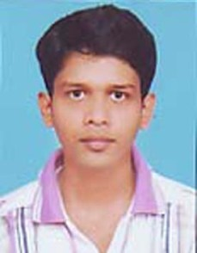
2.FATHER’S NAME : Gourhari Das
3.MOTHER’S NAME : Namita Das
4.DATE OF BIRTH : 10-12-1993
5.SEX : Male
6.CASTE : SC
7.NATIONALITY : Indian
8.MARITAL STATUS : Unmarried
9.RELIGION : Hindu
10.PERMANENT ADDRESS : Vill.+P.O – Alinan, Dist- Purba Medinipur, Pin-
721137, W.B
11.PRESENT ADDRESS : 105,Rabindra SaraniRoad,Durganagar, Kol-49 12.CONTACT NO. : 9932827206
13.LANGUAGE KNOWN : Bengali,English,Hindi
14.EDUCATIONAL QUALIFICATION:-

EXAM  PASSED | YEAR OF  PASSING | UNIVERSITY/BOARD |  | TOTAL  MARKS | PERCENTAGE  (%)
Secondary | 2009 | W.B.B.S.E |  | 514 | 64.25
Higher Secondary | 2011 | W.B.C.H.S.E |  | 316 | 63.2
B.Sc | 2014 | V.U |  | 413 | 51.625
M.Sc | 2016 | W.B.S.U | 783 |  | 65.25

I hereby declare that all the statements mentioned above are true to the best of my knowledge.
DATE:-
PLACE:-
SIGNATURE

